2.5.1 — Identification of All Necessary Buy Parts
- Microcontroller (MCU)
- Printed Circuit Board (PCB)
- Load Cell Connector
- Load Cell Interface Port
- Noise and Low-pass Filter
- Amplifier
- Analog to Digital Converter (ADC) Module
- Cell Excitation Regulator
- Touchscreen Display
- Latching Push Button
- LED light
- Internal Memory Module
- USB-A Port
- Power Regulator
- USB-C Port
- Battery Charging Circuit
- Battery
- Misc Electronics (Passives, Wires, Insulation, Pin headers)
- Protective Carrying Case
- Foam
- 1-Panel Frame
- Internal Aluminium Frame
- Misc Mechanical (Screws, Fasteners, O-rings, Mounting brackets)
- Load cells

2.5.2 Categorise “buy” parts into mechanical and electrical

Electrical BUY Parts

- Microcontroller (MCU)
- Printed Circuit Board (PCB) (the fabricated board is a buy item)
- Load Cell Connector
- Load Cell Interface Port
- Noise and Low-pass Filter
- Amplifier
- Analog to Digital Converter (ADC) Module
- Cell Excitation Regulator
- Touchscreen Display
- Latching Push Button
- LED light
- Internal Memory Module
- USB-A Port
- Power Regulator
- USB-C Port
- Battery Charging Circuit
- Battery
- Misc

Total Electrical Buy Parts: 18

Mechanical BUY Parts

- Protective Carrying Case
- Foam
- 1-Panel Frame
- Internal Aluminium Frame
- Misc (Screws, Fasteners, O-rings, Mounting brackets)
- Load cells

Total Mechanical Buy Parts: 6

Total BUY parts = 24

Requirements Manual for “Buy” Parts

No. | Part | Qty. | Requirements |  | Justification
1 | Microcontroller (MCU) | 1 | • 5 V operation; ≥16 MHz clock; 32 kB Flash, 2 kB SRAM; SPI/I²C/UART interfaces; industrial temperature −40…85 °C. | 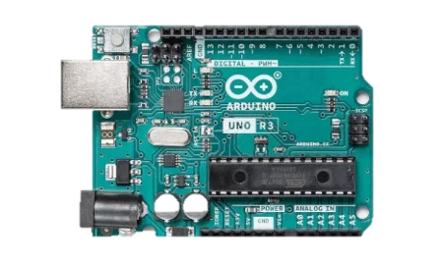
2 | Printed Circuit Board (PCB) | 1 | • FR4 substrate; 1.6 mm thickness; 2–4 copper layers; 1 oz Cu; minimum track/space 0.2 mm; via diameter ≥0.3 mm; ENIG or HASL finish. | 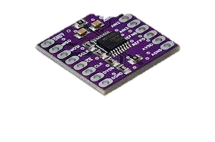
3 | Load Cell Connector | 1 | • Shielded multi-core cable; compatible with Innovatest load-cell wiring; PVC/PUR jacket; −25…80 °C temperature rating; low-resistance copper conductors. | 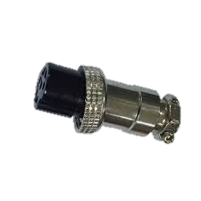
4 | Load Cell Interface Port | 1 | • Panel-mount 5-contact connector; IP67 protection; nickel-plated brass/PA housing; rated current ≥2 A; screw-lock interface. | 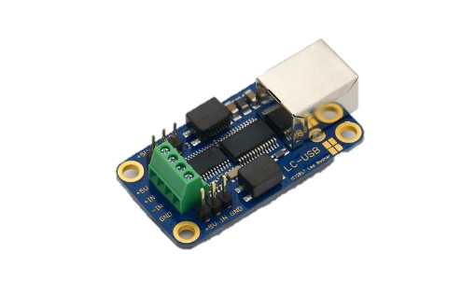
5 | Noise and Low-pass Filter | 1 | • RC/active low-pass filter; cutoff frequency 5–20 Hz; 1–5 % tolerance components; low-noise conditioning for mV-level signals. |  | The use of passive filter allows for greater stability and reliability than active ones. Ensuring only frequencies below 5-20Hz pass eliminates most high frequency noise from the load cell.
6 | Amplifier | 1 | • Differential instrumentation amplifier; gain ≥1000×; CMRR ≥100 dB; input offset <50 µV; input noise density <10 nV/√Hz. | 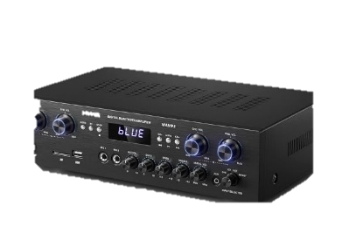
7 | Analog to Digital Converter (ADC) Module | 1 | • 24-bit delta-sigma ADC; differential inputs; SPI interface; effective resolution ≥18 bits; input noise <1 µV RMS. | 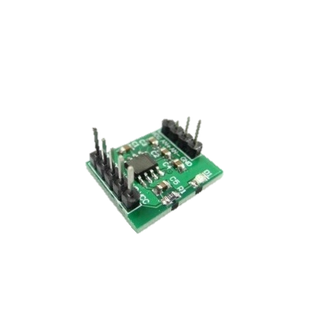
8 | Cell Excitation Regulator | 1 | • Selectable 5 V / 10 V excitation; ripple <10 mVpp; load current ≥50 mA; regulation error <1 %.
9 | Touchscreen Display | 2 | • 10.1″ TFT; 1024×600 resolution; 4-wire resistive touch; ≥300 cd/m² brightness; 5 V supply; SPI/parallel interface. | 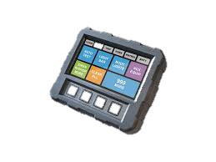
10 | Latching Push Button | 1 | • Panel-mount latching switch; IP65 front; ≥1 A @ 24 VDC; electrical endurance ≥30 000 cycles. | 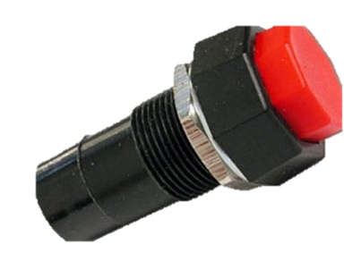
11 | LED light | 1 | • High-brightness LED ≥1000 mcd; forward voltage 2–3 V; daylight-readable output; panel-mount type. | 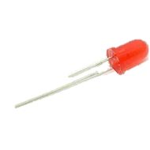
12 | Internal Memory Module | 1 | • ≥8 MB SPI-NOR Flash; 3.3 V operation; ≥100k P/E cycles; data retention ≥20 years. | 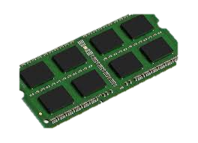
13 | USB-A Port | 1 | • USB-A female connector; USB 2.0 compliant; rated ≥500 mA; insertion life ≥1500 cycles.
14 | Power Regulator | 1 | Linear/DC-DC regulator stage; 5 V and/or 3.3 V outputs; ripple <20 mV; regulation <2 %; continuous output ≥500 mA.
15 | USB-C Port | 1 | USB-C receptacle; 5 V input; mechanical retention ≥8 N; compliant with USB Type-C geometry.
16 | Battery Charging Circuit | 1 | Li-Ion CC/CV charging circuit; 5 V USB-C input; charge current up to 1 A; integrated OV/OC/OT protection.
17 | Battery | 1 | Li-Ion battery ≥5000 mAh; discharge capability ≥2 A; integrated protection (BMS); IEC-compliant cell pack. | 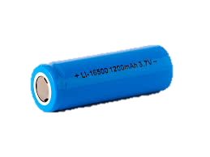
18 | Misc | 1 | Mixed electronic passives: 1 % metal-film resistors; X7R ceramic capacitors; inductors with adequate Q-factor; insulated copper wire rated ≥60 V and −20…80 °C; 2.54 mm pin headers or board-to-wire connectors.

 |  |  |  |  | Justification
1 | Protective Carrying Case | 1 | Polypropylene copolymer case; IP67 rating; pressure equalization valve; internal dimensions ≥420×280×150 mm; impact-resistant hinges and latches. | 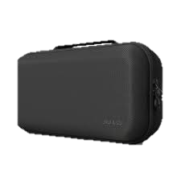
2 | Foam | 1 | EVA/PU foam inserts; density ≥30 kg/m³; CNC/laser-cut cavities; compression-set resistant; thickness matched to internal case profile.
3 | 1-Panel Frame | 1 | Aluminium/steel front panel; 2–3 mm thickness; anodized or powder-coated; cut-outs for display, button, LED; mounting pattern aligned with internal frame. | 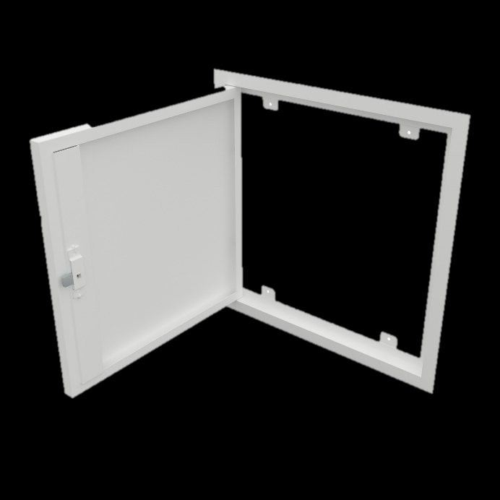
4 | Internal Aluminium Frame | 1 | • Aluminium internal frame; yield strength ≥150 MPa; profiles/sheets supporting PCB, battery, and display; corrosion-protected; vibration-stable structure.
5 | Misc | N./a. | DIN-compliant fasteners (M3–M6); stainless-steel A2/A4 or zinc-plated steel; washers and nuts to EN standards; NBR/EPDM O-rings; steel/aluminium brackets (2–4 mm).
6 | Load cells | 6 | Innovatest load cells; capacity range 150 gf–3000 kgf; full Wheatstone bridge; rated output ≤4 mV/V; excitation 5–10 V; temperature-compensated per Innovatest datasheets. | 